SCREEN SHOT FOR FOLLOWING HEAD PERMIABILITY TEST

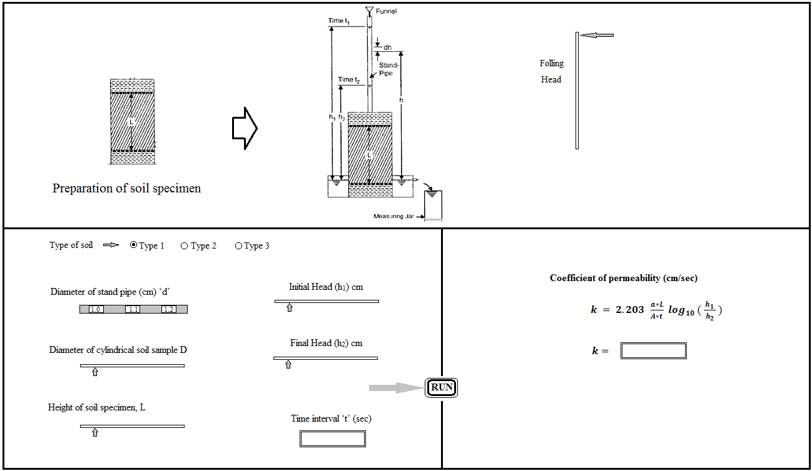

SCREEN SHOT FOR CONSTANT HEAD PERMIABILITY TEST

